TECHNICAL ENGLISH IN 2026

RIKKI J PRINCE

© 2026 Rikki J Prince

All rights reserved. This book is protected by copyright.
No part of it may be reproduced, stored in a retrieval system, or transmitted in any form or by any means, electronic, mechanical, photocopying, recording or otherwise, without prior permission from the Publishers.

ISBN: 9798247712794
Imprint: Independently published on Amazon

Contents

PART I — Core Industrial Technologies
- Industrial Production Lines and Workflow
- Sensors, Measurement, and Data Acquisition
- Automated Packaging Systems
- Robotics in Manufacturing and Assembly
- Programmable Logic Controllers and Control Systems
- Predictive Maintenance and Industrial IoT
- Materials Engineering and Advanced Composites
- Energy Systems and Smart Grids

PART II — Digital & Intelligent Industry
- Industrial Communication Networks and IoT
- Cloud Computing and Industrial Data Analytics
- Cybersecurity in Industrial Systems
- Artificial Intelligence and Machine Learning in Industry
- Additive Manufacturing: From Rapid Prototyping to Advanced Production
- Advanced Digital Twins and Lifecycle Simulation
- Sustainability and Green Engineering
- Human–Machine Collaboration in Modern Industry

PART III — Systems, Operations & Management
- Warehouse Automation and Smart Logistics
- Supply Chain Visibility and Data Integration
- Quality Assurance, Metrology, and Testing
- Standards, Regulation, and Compliance
- Technology Project Management and Risk Control
- The Future Technical Workforce & Industry Trends

Introduction

This book is designed to help learners develop confident, accurate, and practical English for modern technical and professional environments.
Each chapter focuses on a real technology used in today’s workplaces—from automated manufacturing and robotics to digital systems, logistics, and artificial intelligence. Rather than teaching isolated vocabulary, the book presents technical language in context, the way it is actually used by professionals.
The book is suitable for learners who already have a general command of English (CEFR B2 level) and want to use the language professionally in technical fields.
Every chapter follows the same clear structure:
- A short technical scenario
You will read a realistic workplace situation that introduces key concepts and terminology in a natural, accessible way.
- A visual systems task
You will work with diagrams and system illustrations to identify components, understand processes, and connect language to real-world technology.
- Precision vocabulary exercises
You will practice using technical terms accurately through definitions, functions, and typical professional usage.
- A communication task
You will apply what you have learned by discussing a technical problem, explaining a system, or making a decision—just as you would in a real job.
Spelling convention
British spelling was chosen over American spelling for the following reasons:
- It fits international technical education publishing.
- It is consistent with CEFR materials used in Europe & Asia.
If American spellings are preferred, the following changes should be made:
British English American English
Words ending in:
-ise or -isation → -ize and -ization
analyse → analyze
behaviour/colour → behavior/color
modelling/travelling → modeling/traveling
centre/fibre → center/fiber
defence → defense

By the end of this book, you will be able to:
  - Understand and use core technical vocabulary with confidence
  - Describe processes, systems, and problems clearly in English
  - Participate effectively in technical discussions and meetings
  - Explain complex technology to both technical and non-technical audiences

Chapter 1: Industrial Production Lines and Workflow

1. Optimising a Production Line
The production hall was already operating when Elena arrived for the morning shift. As process engineer, her responsibility was to analyse the performance of the assembly line and identify any issues affecting output.
The line consisted of five main stations arranged in sequence. Raw components entered the system at the feeding station, where they were aligned and transferred onto the conveyor belt. From there, the parts moved automatically to the assembly station, where robotic arms carried out the primary operations. Sensors monitored position and alignment, ensuring that each component met the required tolerances before moving forward.
Despite the high level of automation, the line had been underperforming for several weeks. The overall throughput was below target, and unplanned downtime was increasing. Elena reviewed the production data displayed on the control panel. One station showed repeated delays, causing workpieces to accumulate upstream. This congestion forced the conveyor to stop intermittently, reducing efficiency across the entire system.
After observing the line in operation, Elena identified the problem. The inspection station, which used optical sensors to detect surface defects, was processing parts more slowly than expected. When defective items were detected, the rejection mechanism activated correctly, but the system did not resume normal speed immediately. As a result, the inspection station had become a bottleneck.
Elena discussed the issue with the maintenance technician. Together, they considered several corrective actions: recalibrating the sensors, adjusting the conveyor speed, or redistributing tasks between stations. Any solution would need to maintain product quality while restoring a continuous workflow.
Before implementing changes, Elena documented her findings and prepared a short report for the production manager. The objective was clear: eliminate the bottleneck, reduce downtime, and stabilize output without increasing operational risk.

2. Production Line Layout
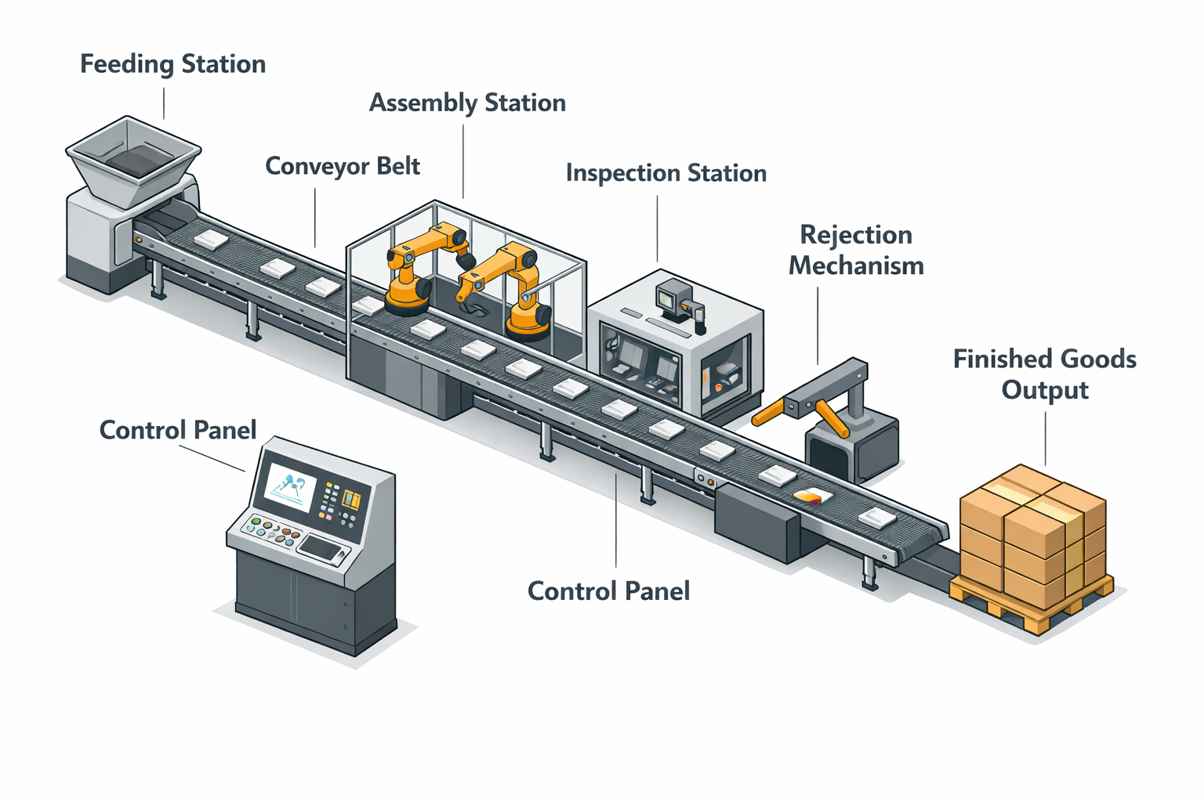
Fig. 1 Industrial production line
Task A — Description of elements
Explain the following elements in the diagram:
- Feeding station
- Conveyor belt
- Assembly station
- Inspection station
- Control panel
- Rejection mechanism
- Finished goods output
Task B — Description of system flow
Describe how a component moves through the system from entry to exit.

3. Precision Vocabulary: Definitions and Usage
Task A — Complete the definitions.
Write the correct technical term for each definition.
- The total number of units produced by a system in a given period of time: __________
- A point in a process where capacity is lower than demand, limiting overall performance: __________
- A temporary halt in production caused by a fault or system interruption: __________
- A device that detects physical properties such as position, presence, or surface condition: __________
- The acceptable limits within which a component must be manufactured: __________
Task B — Match the terms to their functions.
Term | Function
1 Conveyor | a. Controls system parameters and displays operational data
2 Sensor | b. Transfers materials between stations
3 Control panel | c. Identifies defects or misalignment
4 Bottleneck | d. Restricts system throughput

4. Diagnosing a Workflow Problem
Scenario
You are part of a technical team responsible for improving production efficiency. A manufacturing line is failing to meet its output targets due to intermittent stops and uneven material flow.
Task
Working in pairs:
- Identify the most likely cause of the problem.
- Propose one technical solution.
- Explain how your solution improves workflow without reducing quality.
Use at least six technical terms from this chapter.
Refer to specific system components.
Justify your decision clearly and logically.

Chapter Outcome Checklist
By the end of this chapter, you should be able to:
- Describe the structure and function of a basic industrial production line
- Identify bottlenecks and workflow disruptions
- Use core production and automation vocabulary accurately
- Discuss technical problems and propose practical solutions in English

Chapter 2: Sensors, Measurement, and Data Acquisition

1. Monitoring System Performance
During the commissioning phase of a new automated system, accurate measurement was critical. The engineering team needed reliable data to verify that the production line was operating within its design parameters.
Ahmed, a control systems technician, was responsible for configuring the sensors installed along the line. Each station relied on measurement devices to monitor key variables such as position, temperature, pressure, and speed. These sensors transmitted signals to the central controller, where the data was processed and displayed on the monitoring interface.
Shortly after startup, the system generated several warning messages. Although the mechanical components were functioning correctly, the control software reported inconsistent readings from one of the proximity sensors. At times, the sensor failed to detect the presence of a component, causing the controller to stop the conveyor as a safety precaution.
Ahmed began troubleshooting the issue. First, he checked the sensor alignment and mounting position. A slight misalignment can significantly affect detection accuracy, especially at high operating speeds. Next, he reviewed the sensor specifications to confirm that its detection range and response time were suitable for the application.
After recalibrating the sensor, Ahmed observed the signal values in real time. The data stream stabilized, and the false stop events stopped occurring. He documented the incident and updated the system settings to prevent similar issues in the future.
The situation highlighted an important principle: even in highly automated systems, performance depends on the quality of measurement and the correct interpretation of sensor data. Without reliable data acquisition, system control becomes unpredictable and inefficient.

2. Sensor Placement and Signal Flow2. Sensor Placement and Signal Flow

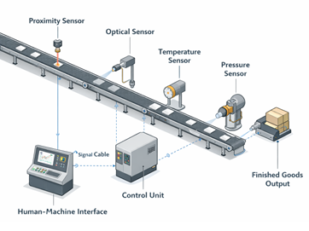
Fig. 2 Production line with multiple sensors
Task A — Description of elements
Look at the illustration of a production line equipped with multiple sensors. Explain what each sensor does:
Proximity sensor
Optical sensor
Temperature sensor
Pressure sensor
Control unit
Signal cable
Human–machine interface (HMI)
Task B — Trace the data flow.
Using the diagram, explain how measurement data moves from the sensors to the control system and how it is used to trigger actions.

3. Precision Vocabulary: Definitions and Control Concepts
Task A — Complete the definitions.
Write the correct technical term for each definition.
A device that detects or measures a physical quantity and converts it into a signal: __________
The process of adjusting a measuring device to improve accuracy: __________
The degree to which a measured value matches the true value: __________
The time delay between a physical change and the sensor’s response: __________
A continuous flow of measurement values sent to a control system: __________
Task B — Choose the correct term.
A sensor that detects the presence of an object without physical contact is a __________ sensor.
Measurement errors caused by poor installation are often related to incorrect __________.
A fast system requires sensors with a short __________ time.

4. Communication Task: Selecting Sensors for an Application
Scenario
You are designing a monitoring system for an automated production line that operates at high speed. The system must detect components accurately and stop the line immediately if a fault occurs.
Task
Working in pairs:
Decide which types of sensors should be used at each station.
Justify your choices based on accuracy, response time, and operating conditions.
Identify one potential measurement problem and explain how it could be prevented.
Use at least six technical terms from this chapter.
Refer explicitly to measurement accuracy and signal reliability.
Present your explanation in a clear, structured way.

Chapter Outcome Checklist
By the end of this chapter, you should be able to:
- Describe how sensors are used to measure physical variables
- Explain basic principles of data acquisition and signal flow
- Identify common causes of measurement errors
- Discuss sensor selection and calibration in technical English

Chapter 3: Automated Packaging Systems and Sensor Control

1. Resolving a Packaging Bottleneck
The packaging section was the final stage of the production process, and any disruption there had an immediate impact on delivery schedules. Unlike upstream stations, packaging systems had to operate continuously and reliably, as finished products could not be stored on the line for long periods.
During a routine performance review, Laura, an automation engineer, noticed that the packaging line was failing to reach its nominal output rate. The system consisted of a conveyor feeding products into a packaging unit, where they were grouped, wrapped, and sealed automatically. A downstream palletizing station stacked the packaged units for transport.
Sensors detected product position and spacing as items entered the packaging unit. A programmable logic controller (PLC) coordinated the movement of actuators responsible for folding, sealing, and cutting the packaging material. In normal operation, the system ran smoothly, with minimal operator intervention.
However, the data logs showed frequent micro-stoppages at the sealing station. Although each stop lasted only a few seconds, the cumulative effect was significant. Laura observed the line during operation and identified the cause: slight variations in product spacing caused the sealing mechanism to activate too early or too late. When this occurred, the PLC stopped the line to prevent damaged packaging.
Laura adjusted the timing parameters and fine-tuned the actuator response. She also recommended installing an additional optical sensor upstream to improve detection accuracy. After implementing these changes, the line stabilized and returned to its target throughput.
The incident demonstrated a key principle of automated packaging systems: high speed and precision require close coordination between sensors, control logic, and mechanical components.

2. Packaging Line Components
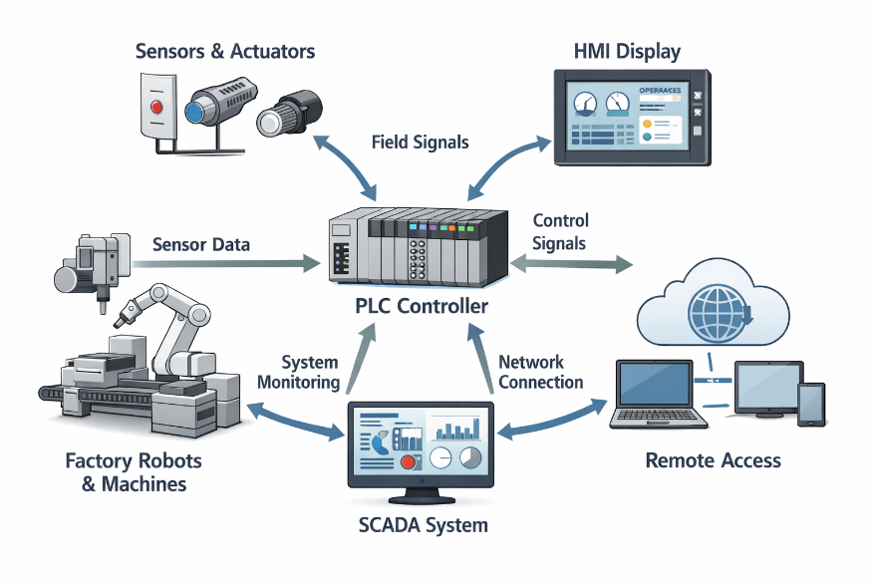
Fig. 3 Automated packaging system
Task A — Explain the following elements, looking up the information when necessary:
Sensors & actuators
HNI display
Factory robots & machines
Remote access
SCADA system
Programmable logic controller (PLC)
Field signals
Sensor data
Control signals
Network connection
System monitoring
Task B — Explain system coordination.
Using the diagram, explain how sensor data is used by the PLC to control packaging operations.

3. Precision Vocabulary: Packaging and Control Terms
Task A — Complete the definitions.
Write the correct technical term for each definition.
A device that converts a control signal into mechanical movement: __________
A short, repeated interruption in system operation: __________
A controller used to automate industrial processes and machinery: __________
The process of closing and securing packaging material: __________
The maximum operating speed a system is designed to achieve: __________
Task B — Select the correct option.
Incorrect product spacing can cause packaging __________ and force the system to stop.
High-speed packaging requires precise __________ between sensors and actuators.
The PLC executes control __________ based on sensor input.

4. Communication Task: Improving Packaging Efficiency
Scenario
An automated packaging line is experiencing frequent minor stops that reduce overall productivity. Product quality must not be compromised.
Task
Working in pairs:
1. Identify the most likely technical cause of the problem.
2. Propose one hardware solution and one software-based solution.
3. Explain how your proposal improves system reliability and throughput.
Use at least six technical terms from this chapter.
Refer explicitly to sensors, actuators, and control logic.
Present your solution clearly and logically, as if reporting to a supervisor.

Chapter Outcome Checklist
By the end of this chapter, you should be able to:
- Describe the structure and function of an automated packaging system
- Explain the interaction between sensors, PLCs, and actuators
- Identify common causes of packaging delays and micro-stoppages
- Propose technical improvements using appropriate professional English

Chapter 4: Robotics in Manufacturing and Assembly

1. Integrating a Robotic Assembly Cell
As demand increased, the manufacturing team decided to upgrade part of the assembly line by introducing an industrial robot. The objective was to improve consistency, reduce manual handling, and increase production speed without expanding floor space.
The robotic cell was installed between the conveyor and the inspection station. A six-axis articulated robot was selected due to its flexibility and reach. Fitted with a mechanical gripper as its end effector, the robot was programmed to pick components from the conveyor, position them accurately, and perform a fastening operation.
During initial testing, the robot operated according to its programmed path, but cycle times were longer than expected. Sofia, a robotics engineer, analysed the movement sequence and identified unnecessary repositioning between tasks. Although the robot’s motions were precise, they were not optimised for speed.
Sofia modified the program to reduce joint rotation and eliminate redundant movements. She also adjusted the interaction between the robot and the upstream sensors so that the robot responded immediately when a component arrived in position. Safety systems, including light curtains and emergency stops, were verified to ensure compliance with operational standards.
After optimisation, the robotic cell achieved a shorter cycle time and improved repeatability. The robot performed each operation consistently, reducing variability and improving overall product quality. The upgrade demonstrated how industrial robots, when correctly programmed and integrated, can significantly enhance manufacturing performance.

2. Robotic Assembly Cell
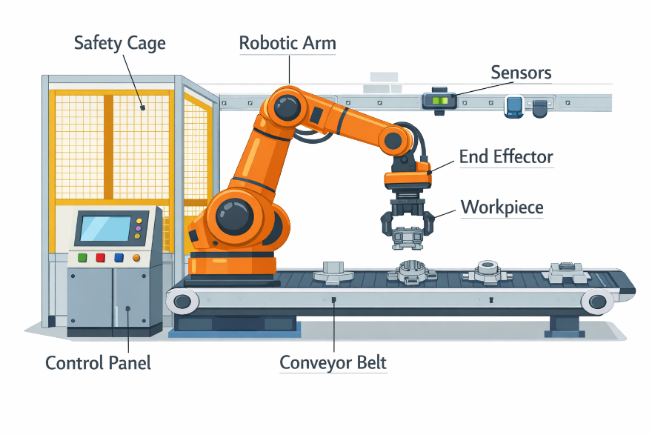Fig. 4 Robotic assembly system
Look at the illustration of the robotic assembly system.
Task A — Explanation
Explain the following elements with the help of the diagram:
- Articulated industrial robot
- Robot base
- End effector (gripper)
- Conveyor interface
- Safety enclosure
- Light curtain
- Control cabinet

Task B — Describe robot operation.
Using the diagram, explain how the robot interacts with the conveyor and how safety systems protect operators and equipment.

3. Precision Vocabulary: Robotics Terminology
Task A — Complete the definitions.
Write the correct technical term for each definition.
- A programmable machine capable of carrying out complex movements automatically: __________
- The tool attached to the robot that interacts with the workpiece: __________
- The time required for a robot to complete one full operation sequence: __________
- The ability of a robot to perform the same task with consistent accuracy: __________
- A safety device that stops operation when an object enters a protected area: __________
Task B — Choose the correct option.
- Reducing unnecessary motion can significantly decrease robot __________ time.
- A robot’s __________ determines how many directions it can move.
- Proper __________ is essential to ensure safe human–robot interaction.

4. Communication Task: Optimising Robotic Performance
Scenario
A robotic assembly cell is meeting quality requirements but is not achieving the desired production speed.
Task
Working in pairs:
- Identify possible causes of slow robotic operation.
- Propose two improvements: one related to programming and one related to system integration.
- Explain how your changes improve efficiency without compromising safety.
Use at least six technical terms from this chapter.
Refer to robot motion, cycle time, and safety systems.
Present your explanation as a short technical briefing.

Chapter Outcome Checklist
By the end of this chapter, you should be able to:
- Describe the structure and function of an industrial robot
- Use key robotics terminology accurately
- Explain how robots are integrated into production lines
- Discuss performance optimisation and safety considerations in English

Chapter 5: PLCs and Control Systems

1. Coordinating an Automated System
As the production line expanded, manual control was no longer sufficient to manage the increasing number of devices. Conveyors, sensors, actuators, and robots all needed to operate in a precise sequence. To ensure reliable coordination, the system relied on a programmable logic controller, or PLC.
During a scheduled upgrade, Marco, a control engineer, was tasked with modifying the PLC program to accommodate a new inspection station. The station required additional sensors and a revised control sequence to prevent collisions between components and robotic arms.
Marco reviewed the existing control logic and identified the relevant input and output signals. Sensors provided input signals indicating component presence, position, and status. Based on this information, the PLC executed programmed instructions and sent output signals to motors, valves, and actuators.
After updating the program, Marco tested the system in simulation mode before deploying it to the live environment. During initial testing, the conveyor stopped unexpectedly when two sensors were activated simultaneously. Marco traced the issue to a logic conflict in the control sequence. By restructuring the conditional statements, he ensured that the system responded correctly to each combination of inputs.
Once the changes were validated, the PLC was switched back to normal operation. The system ran smoothly, with all devices responding in the correct order. The update demonstrated how PLCs function as the central decision-making units in automated systems.

2. PLC-Based Control Architecture
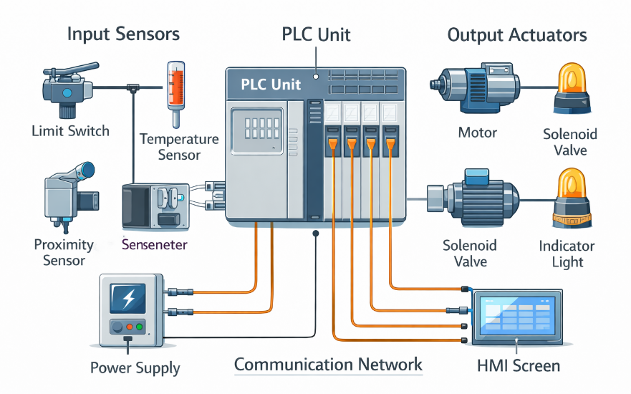
Fig. 5 PLC-controlled system
Look at the illustration of the PLC-controlled system.
Task A — Description of control elements
Explain the following components:
- Programmable logic controller (PLC)
- Input modules
- Output modules
- Sensors
- Actuators
- Conveyor motor
- Human–machine interface (HMI)
Task B — Explain control flow.
Using the diagram, explain how input signals are processed by the PLC and translated into output actions.

3. Precision Vocabulary: Control System Concepts
Task A — Complete the definitions.
Write the correct technical term for each definition.
- A digital industrial controller used to automate processes and machinery: __________
- A signal sent from a sensor to a controller: __________
- A signal sent from a controller to a device that performs an action: __________
- A programmed set of instructions that determines system behaviour: __________
- A graphical interface that allows operators to monitor and control a system: __________
Task B — Choose the correct option.
- PLC programs are typically tested in __________ mode before being deployed.
- Logical conditions such as AND and OR are used to process __________ signals.
- The PLC executes the control __________ repeatedly during operation.

4. Communication Task: Modifying Control Logic
Scenario
An automated system must be updated to include a new station without disrupting existing operations.
Task
Working in pairs:
- Identify which inputs and outputs need to be added to the PLC.
- Describe how the control logic should be modified to integrate the new station.
- Explain how you would test the changes before full deployment.
Use at least six technical terms from this chapter.
Refer explicitly to inputs, outputs, logic, and system testing.
Present your explanation as if reporting during a technical review meeting.

Chapter Outcome Checklist
By the end of this chapter, you should be able to:
- Explain the role of PLCs in automated systems
- Describe basic control architectures and signal flow
- Use essential control-system vocabulary accurately
- Discuss and justify changes to control logic in English

Chapter 6: Predictive Maintenance and IIoT

1. Preventing Unplanned Downtime
Despite a high level of automation, the production line continued to experience unexpected equipment failures. Although faults were repaired quickly, the resulting downtime disrupted schedules and increased maintenance costs.
To address this issue, the company implemented a predictive maintenance strategy based on Industrial Internet of Things (IIoT) technology. Additional sensors were installed on critical components such as motors, bearings, and gearboxes. These sensors continuously measured vibration, temperature, and operating load.
The sensor data was transmitted to a monitoring platform via an industrial network. Instead of reacting to failures, the maintenance team could now analyse trends and detect early signs of wear. When abnormal patterns appeared, the system generated alerts before a breakdown occurred.
Nina, a reliability engineer, reviewed the dashboard each morning. One motor showed a gradual increase in vibration levels over several weeks. Although the motor was still operating within acceptable limits, the trend indicated a potential bearing failure. Nina scheduled maintenance during a planned shutdown, avoiding an unplanned stop.
The introduction of predictive maintenance reduced downtime and improved equipment lifespan. By combining sensor data, connectivity, and analysis, the system transformed maintenance from a reactive activity into a proactive process.

2. IIoT-Based Maintenance Architecture
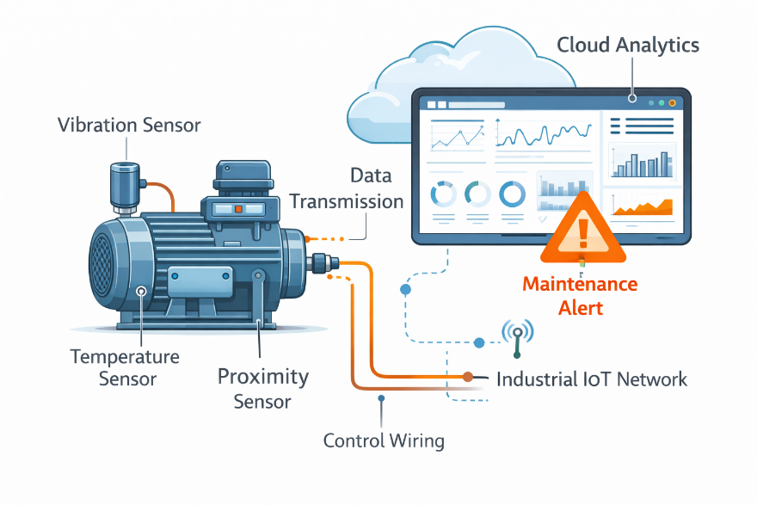
Fig. 6 Predictive maintenance system
Look at the illustration of the predictive maintenance system.
Task A — Label the system components.
Identify and point out the following elements:
- Vibration sensor
- Temperature sensor
- Industrial motor
- Edge device / data gateway
- Industrial network
- Monitoring platform
- Maintenance dashboard
Task B — Describe data flow.
Using the diagram, explain how sensor data is collected, transmitted, analysed, and converted into maintenance actions.

3. Precision Vocabulary: Maintenance and Connectivity
Task A — Complete the definitions.
Write the correct technical term for each definition.
- Maintenance carried out based on predicted equipment condition rather than failure: __________
- A network of connected industrial devices that collect and exchange data: __________
- The continuous measurement of machine condition over time: __________
- A measurable pattern indicating a developing fault: __________
- A planned interruption of production for servicing or inspection: __________
Task B — Choose the correct option.
- Predictive maintenance relies on __________ analysis rather than fixed schedules.
- An IIoT system often uses a local __________ device to process data close to the machine.
- Early fault detection helps reduce unplanned __________.

4. Communication Task: Implementing Predictive Maintenance
Scenario
A factory currently uses time-based maintenance and experiences frequent unexpected failures.
Task
Working in pairs:
- Identify which equipment should be monitored first and why.
- Propose the types of sensors required.
- Explain how predictive maintenance would reduce costs and improve reliability.
Use at least six technical terms from this chapter.
Refer explicitly to data collection, trends, and maintenance planning.
Present your proposal as a short technical justification to management.

Chapter Outcome Checklist
By the end of this chapter, you should be able to:
- Explain the principles of predictive maintenance
- Describe how IIoT systems collect and transmit industrial data
- Use maintenance and connectivity terminology accurately
- Discuss the benefits of data-driven maintenance strategies in English

Chapter 7: Materials Engineering and Advanced Composites

1. Selecting Materials for Performance
After validating the prototype design, the engineering team needed to select materials for full-scale production. The component would operate under mechanical load and elevated temperature, so material choice was critical.
Several options were evaluated, including metals, polymers, and composite materials. While traditional metals offered strength and durability, they increased overall weight. Polymers reduced weight but had limited temperature resistance. Advanced composites provided a balance between strength, stiffness, and weight, making them suitable for the application.
Maria, a materials engineer, analysed the performance requirements and compared material data sheets. She considered properties such as tensile strength, thermal resistance, fatigue life, and cost. In addition, she assessed how each material would behave during manufacturing and long-term operation.
After testing several samples, the team selected a fibre-reinforced composite. Although the material was more expensive, its performance advantages justified the cost. The decision demonstrated how materials engineering plays a key role in modern product development.

2. Material Structure and Application
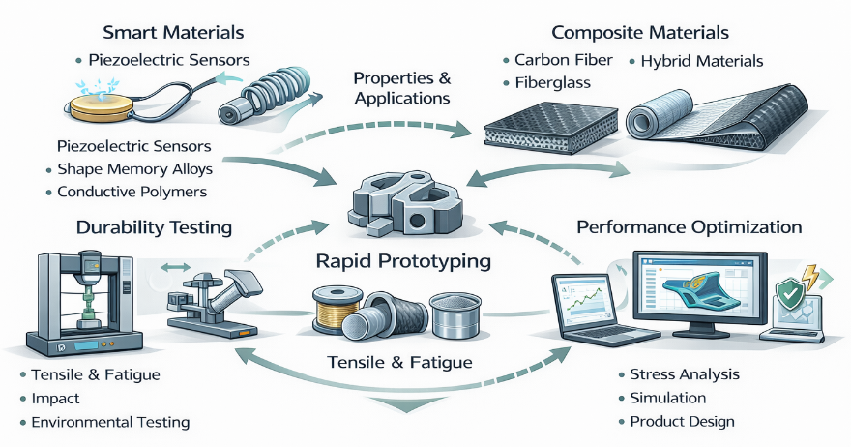
Fig. 7 Materials engineering and composites overview
Task A — Describing materials
Explain the difference between smart materials and composite materials
Task B — Explaining processes
Explain the processes of durability testing, rapid prototyping and performance optimisation.

3. Precision Vocabulary: Material Properties
Task A — Complete the definitions.
Write the correct technical term for each definition.
- The ability of a material to resist being pulled apart: __________
- The relationship between stress and deformation: __________
- Resistance to repeated loading over time: __________
- A material made from two or more distinct constituents: __________
- The maximum temperature a material can withstand in operation: __________
Task B — Choose the correct option.
- Composite materials combine fibres and a __________ material.
- High __________ strength is essential for load-bearing components.
- Material selection must consider both performance and __________.

4. Communication Task: Justifying Material Selection
A design review meeting is being held to finalize material selection for a new component.
Task
Working in pairs:
- Compare two material options for the application.
- Justify the final material choice based on performance and cost.
- Identify one potential risk related to material behaviour.
Use at least six technical terms from this chapter.
Refer explicitly to material properties and operating conditions.
Present your justification clearly and logically.

Chapter Outcome Checklist
By the end of this chapter, you should be able to:
- Describe key material properties and their impact on performance
- Explain the structure and advantages of composite materials
- Use materials engineering terminology accurately
- Justify material selection decisions in professional English

Chapter 8: Energy Systems and Smart Grids

1. Managing Energy in an Integrated System
Modern energy systems increasingly integrate renewable generation, energy storage, and smart grid technologies to balance supply and demand efficiently. At a large solar farm, electricity flows into the central grid while voltage, frequency, and current are continuously monitored by sensors. Batteries store surplus energy for use during peak demand periods. Grid management software coordinates the flow, ensuring stability and preventing overloads. Engineers analyse consumption patterns and adjust distribution in real time.
Smart meters in homes and factories communicate usage data, enabling dynamic pricing and demand response. Predictive analytics help maintenance teams identify potential failures in transformers, switches, or lines before they occur. Automated alerts and diagnostics improve reliability and uptime. By combining generation, storage, monitoring, and control, modern grids optimise resource use, reduce waste, and support renewable integration.
The system also enables rapid response to sudden changes in demand or supply, improving resilience. Operators use dashboards to visualize energy flows, identify bottlenecks, and make strategic decisions. Overall, smart grids increase efficiency, support environmental objectives, and maintain secure and continuous energy delivery across all connected facilities.

2. Smart Grid Architecture
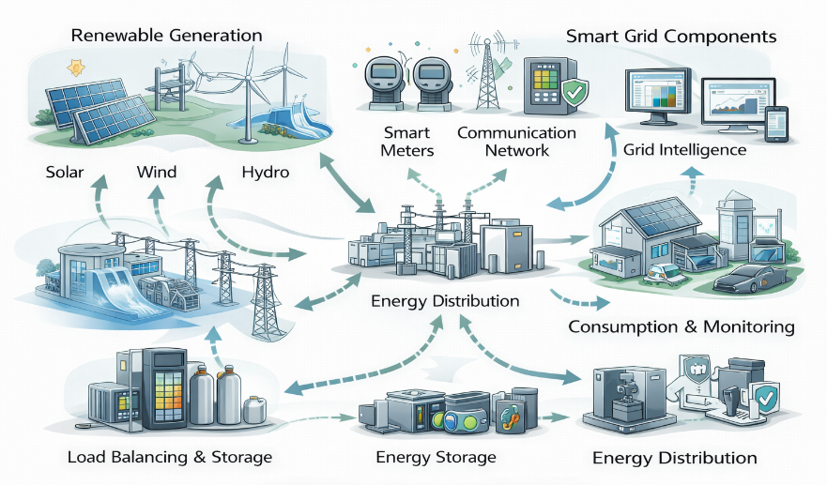
Fig. 8 Energy systems and smart grids

Look at the illustration of a smart grid connected to an industrial facility.
Task A — Identify system components.
Label the following elements:
- Power generation unit
- Renewable energy source
- Energy storage system
- Distribution network
- Control and monitoring system
- Industrial load

Task B — Describe energy flow.
Using the diagram, explain how energy flows from generation to consumption and how feedback data is used to optimise the system.

3. Precision Vocabulary: Energy and Power Management
1. Match the term (A) to its definition (B).
A
1. Smart grid
2. Load balancing
3. Dynamic pricing
4. Predictive analytics
5. Energy storage
B
  - Using data models to forecast failures or demand
b. Adjusting supply and demand to prevent overloads
c. A digital electricity network with real-time monitoring
d. Batteries or systems that store electricity for later use
e. Pricing that changes according to demand and availability
2. Fill in the blanks:
- Batteries store ______ energy for use during ______ demand periods.
- Engineers use ______ to forecast potential grid failures.
- 3. Short-answer:
Explain how smart meters help optimise energy consumption.

4. Communication Task: Proposing an Energy Optimisation Plan
Scenario
Your company wants to reduce energy costs and carbon emissions at an industrial site.
Task
Prepare a short technical proposal that:
- Identifies two weaknesses in the current energy system.
- Recommends one renewable energy solution.
- Explains how smart grid technology would improve efficiency and reliability.
Use at least six technical terms from this chapter.
Refer to energy flow, monitoring, and control.
Use clear, professional technical English.

Chapter Outcome Checklist
By the end of this chapter, you should be able to:
- Describe the structure and function of modern energy systems
- Explain the principles of smart grids and energy management
- Use energy-related technical vocabulary accurately
- Propose improvements to industrial energy systems

Chapter 9: Industrial Communication Networks and IoT

1. Connecting Machines and Systems
In modern manufacturing, automation and robotics are central to achieving high productivity and precision. Robotic cells perform repetitive assembly tasks, including welding, painting, and material handling, while programmable logic controllers (PLCs) coordinate timing, motion, and safety interlocks. Sensors measure critical variables, providing feedback that ensures accuracy and repeatability. Human–machine interfaces (HMIs) display system status, operational parameters, and alerts to engineers.
Safety zones and emergency stop systems prevent accidents, protecting personnel and equipment. Continuous monitoring allows early detection of faults, reducing downtime. Integration between multiple robotic cells, conveyors, and control systems ensures smooth workflow across production lines. Engineers can adjust process parameters remotely, analyse performance data, and optimise task sequences.
The use of automation and control systems increases throughput, enhances product quality, and reduces the risk of human error. Predictive maintenance tools analyse sensor data to anticipate component wear or failure. By combining robotics, sensors, PLCs, and HMIs, manufacturers achieve consistent, reliable production while improving safety and operational efficiency.

2. Industrial Automation
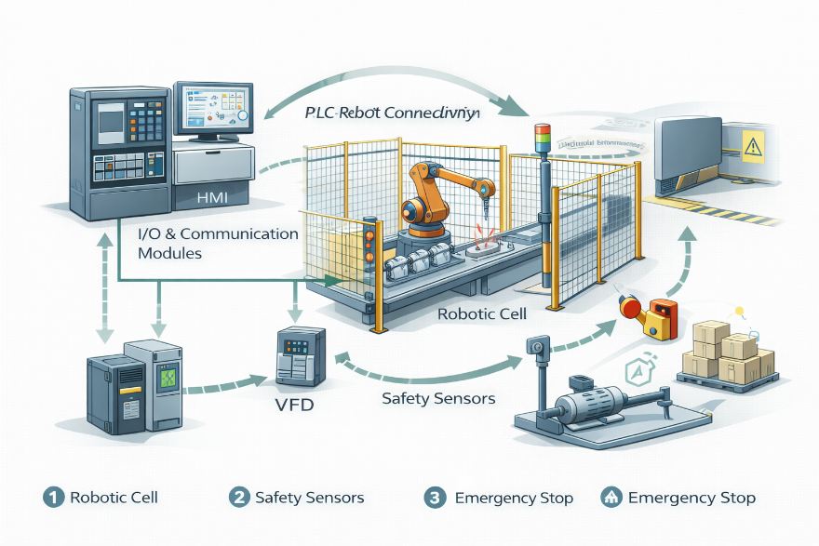
Fig. 9 Industrial automation in modern manufacturing
Vocabulary & Key Terms
Robotic cell – A work area where robots perform specific automated tasks.
Programmable Logic Controller (PLC) – A digital computer that controls machinery and automation processes.
Human–Machine Interface (HMI) – A display system that allows operators to monitor and control machinery.
Safety zone – A defined area where humans and robots interact safely or are restricted.
Predictive maintenance – Using sensor data to anticipate equipment failures before they occur.
Sensors – Devices that detect variables like temperature, pressure, or motion and provide feedback.
Emergency stop – A safety mechanism to immediately halt machinery in dangerous situations.
Throughput – The amount of production output within a given time.
Integration – Coordinating multiple systems or machines to work together efficiently.
Workflow optimisation – Adjusting tasks, sequences, and machinery to maximize productivity and quality.

Section 3 – Exercises
1. Match the term (A) to its definition (B).
A
- PLC
- HMI
- Robotic cell
- Predictive maintenance
- Emergency stop
B
a. A system that anticipates failures using sensor data
b. A device that immediately halts machinery for safety
c. A computer that controls automated processes
d. A display used to monitor and control machines
e. A workspace where robots perform specific tasks
2. Fill in the blanks:
- The ______ allows operators to monitor system status.
- Sensors provide feedback to ensure ______ and repeatability.
3. Short-answer:
Why does predictive maintenance reduce downtime?

Section 4 – Discussion / Pair Activity
Imagine you are designing a new automated assembly line. Work in pairs and discuss:
- Which processes should be automated and why?
- How would you design safety zones and emergency stop protocols?
- How can HMIs and dashboards support operators in monitoring production?
- What strategies would you use to integrate multiple robotic cells into one efficient workflow?
Use the vocabulary from Section 2 during your discussion.

Chapter Outcome Checklist
By the end of this chapter, you should be able to:
- Describe industrial communication networks and their components
- Explain the principles of IIoT and edge computing
- Use core industrial networking terminology accurately
- Discuss the benefits of connected industrial systems

Chapter 10: Cloud Computing and Industrial Data Analytics

1. Turning Data into Insight
Modern industrial operations generate massive amounts of data from sensors, production equipment, and logistics systems. Cloud computing provides centralized storage, scalable processing, and remote accessibility, enabling engineers to analyse this data efficiently. Industrial data analytics identifies trends, detects anomalies, predicts equipment failures, and optimises production performance.
Distributed cloud architectures ensure system reliability and minimize downtime, even during peak demand. Dashboards display key performance indicators (KPIs) and operational metrics, helping managers and engineers make informed decisions. Latency and bandwidth are monitored to maintain real-time responsiveness for critical control systems. Integration of multiple plants into a unified platform allows centralized analysis of processes, energy usage, and supply chain metrics.
Predictive models support maintenance planning, resource allocation, and workflow optimisation. Engineers use analytics to identify bottlenecks, reduce waste, and improve throughput. By combining cloud computing and industrial data analytics, organizations achieve smarter decision-making, faster responses to production challenges, and higher overall efficiency across operations. Centralized access to accurate, up-to-date information enhances collaboration between teams and supports continuous process improvement.

2. Cloud-Based Industrial Architecture
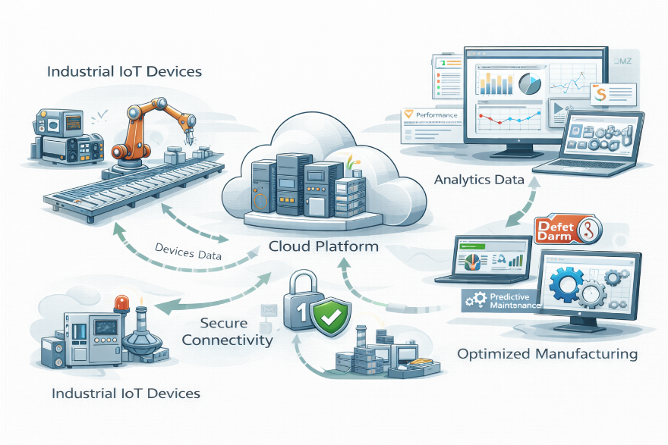
Fig. 10 Smart manufacturing with cloud analytics
Vocabulary & Key Terms
Cloud computing – Delivery of computing services (storage, processing, networking) over the internet.
Industrial data analytics – Analysis of operational and production data to improve performance.
Key Performance Indicator (KPI) – A measurable value that demonstrates how effectively a process is achieving objectives.
Latency – Delay between a data request and its response.
Bandwidth – The capacity for data transfer in a network.
Predictive model – A statistical or machine learning model that forecasts future events based on data.
Real-time monitoring – Continuous observation and analysis of data as it is generated.
Integration – Combining multiple systems to operate seamlessly.
Bottleneck – A point in a process that limits overall system performance.
Workflow optimisation – Adjusting procedures and resources to improve efficiency and reduce delays.

Section 3 – Exercises
1. Match the term (A) to its definition (B).
A
- Cloud computing
- KPI
- Latency
- Predictive model
- Bottleneck
B
a. A measurable value indicating system performance
b. A delay between data request and response
c. Centralized computing services delivered over the internet
d. A data model used to forecast future events
e. A process stage that limits overall efficiency
2. Fill in the blanks:
a. Distributed architectures improve ______ and reliability.
b. Engineers use ______ to identify bottlenecks and inefficiencies.
3. Short-answer:
How does cloud integration support multi-site operations?

Section 4 – Discussion / Pair Activity
Imagine your company is migrating its industrial systems to the cloud. Work in pairs and discuss:
- What types of data should be collected and analysed?
- How would KPIs be selected to monitor production performance?
- What strategies would ensure low latency and high reliability?
- How can predictive analytics support maintenance and optimise workflows?
Use the vocabulary from Section 2 during your discussion.

Chapter Outcome Checklist
By the end of this chapter, you should be able to:
- Describe cloud-based industrial architectures
- Explain the role of data analytics in manufacturing
- Use cloud and data-related technical vocabulary accurately
- Evaluate cloud solutions in engineering contexts

Chapter 11: Cybersecurity in Industrial Systems

1. Securing the Smart Factory
Industrial networks face constant threats from malware, ransomware, and insider errors, which can disrupt production and compromise safety. Critical components of industrial cybersecurity include firewalls, intrusion detection systems, and robust access controls. Network segmentation separates operational technology (OT) from office IT systems to prevent lateral attacks. Engineers continuously monitor logs and alerts to detect anomalies or suspicious activity. Authentication policies enforce secure access, and regular updates patch vulnerabilities.
Backup systems preserve critical configurations and production data. Cybersecurity measures also include physical security controls, incident response plans, and employee training. Threat intelligence feeds inform proactive protection strategies. Effective cybersecurity protects both digital assets and the physical machinery they control, ensuring operational continuity. Regular audits and compliance checks verify that policies are effective.
By combining technological safeguards with human oversight, industrial organizations reduce the likelihood of attacks, minimize downtime, and maintain safe, reliable production processes. Secure network design also supports remote monitoring and cloud integration, enabling safe data access without compromising system integrity. Overall, cybersecurity is essential to sustain industrial operations, protect investments, and ensure worker safety.

2. Industrial Cybersecurity Architecture
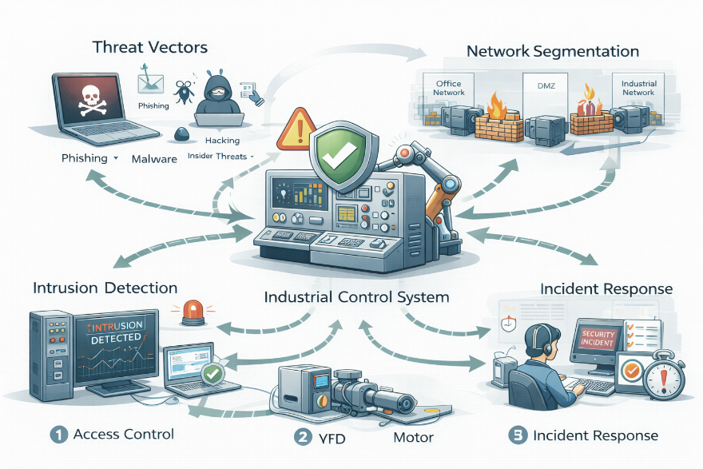
Fig. 11 Cybersecurity in industrial systems
Vocabulary & Key Terms
Firewall – A network security device that monitors and controls incoming and outgoing traffic.
Intrusion Detection System (IDS) – Software or hardware that detects malicious activity or policy violations.
Access control – Methods for ensuring only authorized personnel can access systems or data.
Network segmentation – Dividing a network into separate zones to limit potential security breaches.
Operational Technology (OT) – Hardware and software controlling industrial machinery.
Authentication – Verification process to confirm the identity of a user or device.
Backup system – Copies of data and configurations stored to recover from failures or attacks.
Threat intelligence – Information about current or emerging cybersecurity threats.
Incident response – Procedures to handle and mitigate security breaches.
Compliance audit – Systematic evaluation to ensure adherence to policies, standards, or regulations.

Section 3 – Exercises
1. Match the term (A) to its definition (B).
A
- Firewall
- IDS
- Network segmentation
- Access control
- Incident response
B
a. Procedures for handling security breaches
b. Dividing a network into isolated zones
c. A system that detects suspicious activity
d. Rules that limit system access to authorized users
e. A device that filters incoming and outgoing traffic
2. Fill in the blanks:
- Engineers use ______ to detect abnormal network behaviour.
- ______ prevents unauthorized users from accessing OT systems.
3. Short-answer:
Why is network segmentation important in industrial environments?

Section 4 – Discussion / Pair Activity
Imagine a manufacturing plant is upgrading its cybersecurity. Work in pairs and discuss:
- Which critical systems should be monitored continuously?
- How would you implement access control policies for engineers, operators, and administrators?
- What measures can protect OT from attacks originating in office IT networks?
- How should staff respond in case of a detected cybersecurity incident?
Use the vocabulary from Section 2 during your discussion.

Chapter Outcome Checklist
By the end of this chapter, you should be able to:
- Explain cybersecurity challenges in industrial systems
- Describe layered defence strategies
- Use technical cybersecurity vocabulary accurately
- Discuss security planning in engineering contexts

Chapter 12: Artificial Intelligence and Machine Learning in Industry

1. Intelligent Decision-Making on the Factory Floor
Artificial intelligence (AI) and machine learning (ML) are transforming industrial operations by analysing production data to identify patterns, predict equipment failures, and optimise processes. ML algorithms classify defects, forecast demand, and suggest adjustments in real time. AI systems integrate with programmable logic controllers (PLCs), sensors, and control systems to automate decision-making. Engineers review AI outputs to ensure safety, accuracy, and feasibility.
Neural networks and predictive models detect subtle deviations, enabling proactive maintenance. AI supports quality assurance, reducing defective products and improving overall efficiency. Human oversight remains essential for interpreting AI recommendations, validating predictions, and adjusting parameters when conditions change. The combination of AI, ML, and real-time data analytics allows continuous improvement in production speed, reliability, and resource utilization.
Industrial organizations benefit from faster troubleshooting, predictive maintenance, and optimised workflow sequencing. By embedding intelligence into machinery and control systems, companies achieve higher productivity, lower costs, and safer operations, while retaining human control over critical decision points.

2. AI-Enabled Industrial System
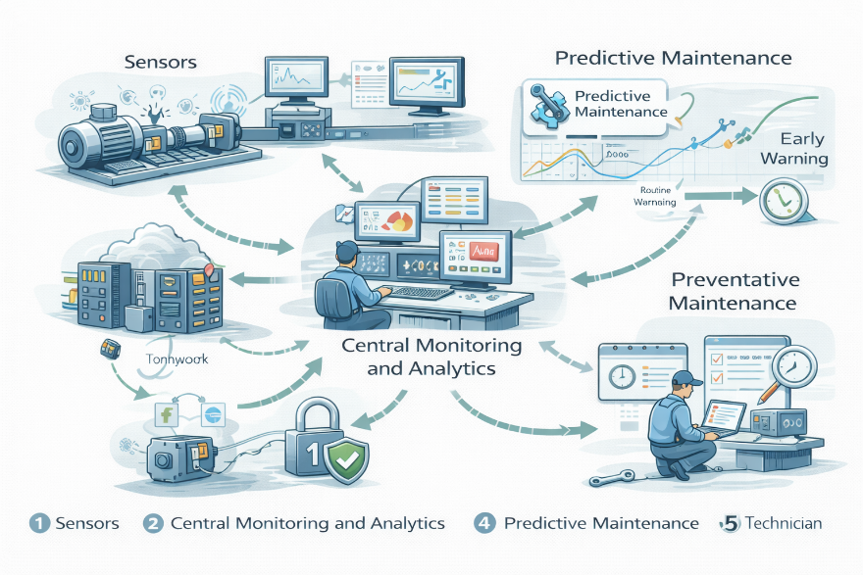
Fig. 12 Artificial Intelligence and Machine Learning Integration in Industrial Systems
Vocabulary & Key Terms
Artificial intelligence (AI) – Computer systems capable of performing tasks that typically require human intelligence.
Machine learning (ML) – A subset of AI where systems improve performance by learning from data.
Neural network – A computational model inspired by the human brain for pattern recognition.
Predictive model – A model that forecasts future events using historical and real-time data.
Defect detection – Identifying products or components that do not meet quality standards.
Proactive maintenance – Actions taken to prevent equipment failures before they occur.
Integration – Combining AI with sensors, PLCs, and control systems for automated decisions.
Human oversight – Monitoring and validating AI outputs to ensure accuracy and safety.
Workflow sequencing – Ordering tasks and processes for optimal efficiency.
Real-time data analytics – Processing and analysing data instantly as it is collected.

Section 3 – Exercises
1. Match the term (A) to its definition (B).
A
- Artificial intelligence
- Machine learning
- Neural network
- Proactive maintenance
- Human oversight
B
a. Maintenance actions taken before failures occur
b. Systems that perform tasks requiring human-like reasoning
c. Monitoring and validating AI decisions
d. AI models inspired by the human brain
e. Algorithms that improve through data experience
2. Fill in the blanks:
- ______ algorithms analyse production data to detect patterns.
- Engineers maintain ______ to ensure safe AI decisions.
3. Short-answer:
How does AI improve defect detection in manufacturing?

Section 4 – Discussion / Pair Activity
Imagine your production plant is integrating AI systems. Work in pairs and discuss:
- Which production tasks are most suitable for AI automation?
- How can predictive models reduce downtime and defects?
- How should human oversight be maintained to ensure safety and quality?
- How can real-time data analytics support continuous improvement?
Use the vocabulary from Section 2 during your discussion.

Chapter Outcome Checklist
By the end of this chapter, you should be able to:
- Explain AI and machine learning concepts in industrial contexts
- Describe how learning systems support engineering decisions
- Use AI-related technical vocabulary accurately
- Discuss benefits and limitations of AI in industry

Chapter 13: Additive Manufacturing: From Rapid Prototyping to Advanced Production

1. From Digital Design to Industrial Production
Additive manufacturing, commonly known as 3D printing, has transformed how engineers design, test, and produce components. Instead of removing material through cutting or machining, additive processes build objects layer by layer directly from a digital model. This approach enables complex geometries, rapid prototyping, and reduced material waste.
In early product development, engineers create three-dimensional designs using computer-aided design (CAD) software. The model is processed by slicer software, which divides the geometry into thin layers and generates instructions for the printing system. A 3D printer then deposits or fuses material according to these instructions until the component is complete.
Rapid prototyping allows teams to evaluate fit, function, and performance before committing to full-scale production. Design changes can be implemented quickly, reducing development time and cost. Post-processing operations—such as heat treatment, machining, or surface finishing—improve dimensional accuracy, strength, and durability.
Modern additive manufacturing is increasingly used for final production parts, especially in aerospace, medical, and high-performance engineering. Advanced metal printing, hybrid additive–subtractive systems, and in-process monitoring enable reliable industrial production. As a result, additive manufacturing is evolving from a prototyping tool into a strategic manufacturing technology.

2. Additive Manufacturing Workflow
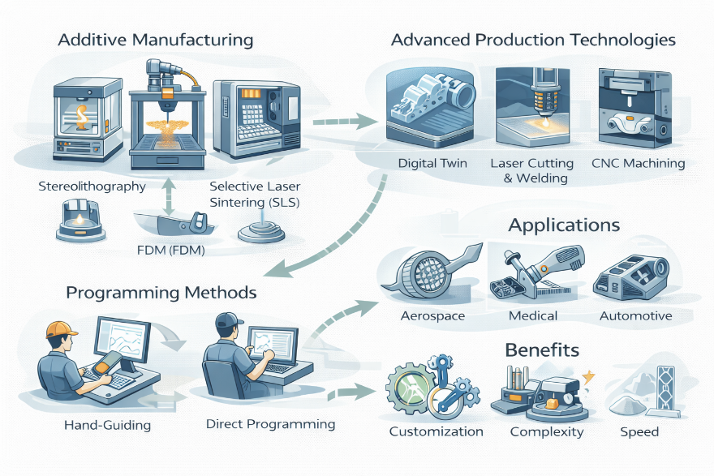
Fig. 13 Additive manufacturing process from CAD model to finished component
Task A — Identify process stages
Explain what the following elements are:
- CAD workstation
- Slicer software
- Additive manufacturing machine
- Build platform
- Material feedstock
- Finished component
- Post-processing station
Task B — Compare additive technologies
Explain the differences between:
- Fused Deposition Modelling (FDM)
- Stereolithography (SLA)
- Laser sintering of polymers
- Electron beam melting (EBM) of metals
Discuss how material type, accuracy, production speed, and cost influence technology selection.

3. Precision Vocabulary: Additive Manufacturing
Task A — Complete the definitions
- A manufacturing process that creates objects layer by layer: __________
- A digital three-dimensional representation of a component: __________
- Software that converts a model into printable layers: __________
- Operations performed after printing to improve quality: __________
- Acceptable dimensional variation in a manufactured part: __________
- Monitoring of the build process during printing: __________
Task B — Choose the correct option
- Metal additive parts often require additional __________ treatment to improve strength.
- Hybrid manufacturing combines additive processes with traditional __________ machining.
- Complex internal __________ are easier to produce additively than subtractively.

4. Communication Task: Evaluating Additive Manufacturing
Scenario
A company is considering replacing a traditionally machined component with an additively manufactured version.
Task
Prepare a short technical recommendation that:
- Identifies two advantages of additive manufacturing
- Describes one limitation or risk
- Explains how post-processing and monitoring ensure quality
Use at least six technical terms from this chapter.
Refer to materials, tolerances, and production scale.
Present your conclusion in clear professional English.

Chapter Outcome Checklist
By the end of this chapter, you should be able to:
- Explain the additive manufacturing workflow from CAD to finished part.
- Distinguish between major additive technologies and applications.
- Use additive manufacturing vocabulary accurately.
- Evaluate when additive manufacturing is suitable for industrial production.

Chapter 14: Digital Twins: Simulation, Optimisation, and Lifecycle Intelligence

1. Connecting Physical Systems to Virtual Models
Digital twin technology creates a dynamic virtual representation of a physical system that updates continuously using real-time data. Sensors installed on machines measure variables such as temperature, vibration, position, and energy consumption. This data is transmitted to a digital model, allowing engineers to observe system behaviour without direct physical intervention.
At a basic level, digital twins enable simulation and performance analysis. Engineers can test operating conditions, adjust parameters, and predict outcomes before applying changes to the real system. This reduces operational risk, prevents downtime, and supports informed decision-making.
At a more advanced level, digital twins extend across the entire lifecycle of an asset—from design and commissioning to operation, maintenance, and replacement. Predictive analytics detect anomalies and forecast failures, enabling proactive maintenance strategies. Integration with cloud computing and artificial intelligence further improves optimisation and system insight.
By combining simulation, real-time monitoring, and lifecycle data, digital twins transform industrial management from reactive control into intelligent, data-driven optimisation.

2. Digital Twin Architecture and Data Flow
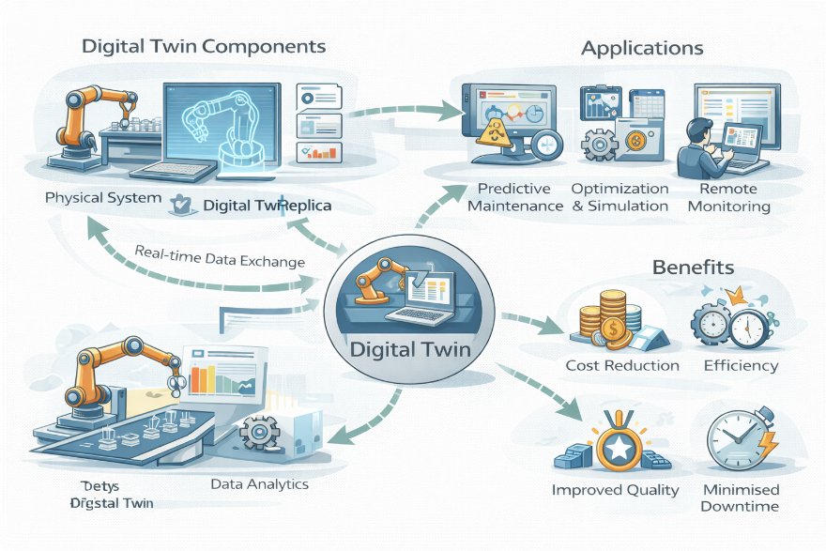
Fig. 14 Digital twin system linking physical assets, sensors, cloud data, and simulation models
Task A — Identify system components
Explain the role of:
- Physical asset or production line
- Embedded sensors
- Industrial communication network
- Digital twin model
- Simulation engine
- Performance dashboard
- Cloud data platform
Task B — Explain lifecycle integration
Describe how a digital twin supports:
- Commissioning and testing
- Real-time operational monitoring
- Predictive maintenance
- Long-term lifecycle management

3. Precision Vocabulary: Simulation and Lifecycle Management
Task A — Complete the definitions
- A virtual model that mirrors a physical system in real time: __________
- The imitation of system behaviour under defined conditions: __________
- A measurable value used to evaluate performance: __________
- An unexpected deviation from normal operation: __________
- Maintenance based on predicted future condition: __________
- Managing an asset from design to retirement: __________
Task B — Choose the correct option
- Digital twins rely on continuous __________ input from sensors.
- Simulation allows engineers to test changes without interrupting __________ production.
- Predictive analytics help identify potential __________ before failure occurs.

4. Communication Task: Using Digital Twins for
Decision-Making
Scenario
A production manager wants to increase output while reducing maintenance cost and operational risk.
Task
Prepare a short technical briefing that:
- Explains how a digital twin can simulate higher production rates
- Identifies two lifecycle benefits
- Justifies why data-driven predictions are reliable
Use at least six technical terms from this chapter.
Refer to simulation, anomalies, and predictive maintenance.
Present your explanation in clear professional English.

Chapter Outcome Checklist
By the end of this chapter, you should be able to:
- Describe how digital twins connect physical assets with virtual models.
- Explain simulation, optimisation, and predictive maintenance.
- Use lifecycle and performance terminology accurately.
- Evaluate the strategic value of digital twins in modern industry.

Chapter 15: Sustainability and Green Engineering

1. Designing for Environmental Impact
Sustainability and green engineering focus on designing industrial systems that minimize environmental impact while maintaining technical and economic viability. In a modern production facility, sustainability principles are applied from the earliest design stages through to end-of-life disposal. Engineers evaluate material selection, energy consumption, water usage, and waste generation to reduce the overall ecological footprint of the operation.
A key practice is life-cycle assessment (LCA), which quantifies environmental impacts across all stages of a product’s life, including raw material extraction, manufacturing, distribution, use, and disposal. Using LCA data, engineers can compare design alternatives and identify opportunities for improvement. For example, substituting lightweight materials may reduce transportation emissions, while redesigning processes can lower energy demand during manufacturing.
Green engineering also promotes resource efficiency through recycling, remanufacturing, and closed-loop systems. Industrial waste streams are increasingly treated as valuable inputs rather than disposal problems. In parallel, renewable energy sources and energy recovery systems are integrated into industrial sites to reduce dependence on fossil fuels. Together, these approaches enable organizations to meet regulatory requirements, reduce costs over time, and align production with long-term environmental goals.

2. Sustainable Industrial System
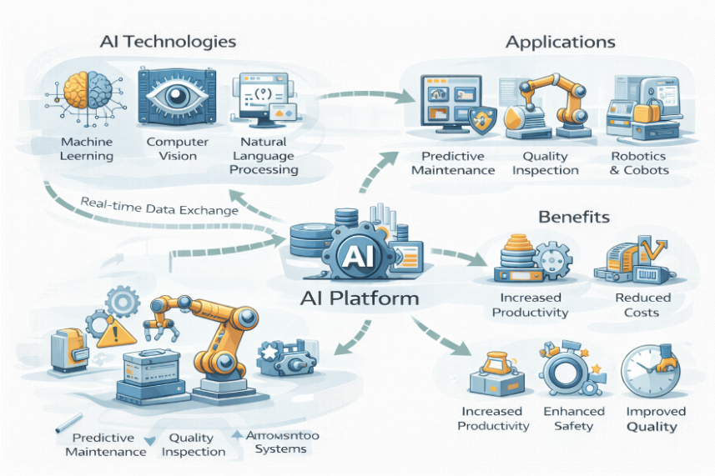
Fig. 15 Sustainable Engineering and Green Industrial Systems
Vocabulary & Key Terms
Sustainability – Meeting present needs without compromising future resources.
Green engineering – Engineering practices that minimize environmental impact.
Life-cycle assessment (LCA) – Evaluation of environmental impacts across a product’s entire life.
Resource efficiency – Achieving maximum output from minimal resource input.
Closed-loop system – A system where waste is reused as input.
Renewable energy – Energy derived from naturally replenished sources.
Environmental footprint – The total environmental impact of an activity or product.

Section 3 – Exercises
1. Match the term (A) to its definition (B).
A
- Life-cycle assessment
- Green engineering
- Closed-loop system
- Resource efficiency
- Environmental footprint
B
a. Total environmental impact of a product or activity
b. System that reuses waste as input
c. Evaluation of impacts across all life stages
d. Engineering aimed at reducing ecological harm
e. Maximizing output while minimizing resource use
2. Complete the sentences:
- LCA helps engineers compare different ______ alternatives.
- Renewable energy reduces dependence on ______ fuels.
3. Short-answer:
Why is life-cycle assessment critical in sustainable design?

Section 4 – Discussion / Application
Discuss the following:
- How can sustainability improve long-term industrial competitiveness?
- What trade-offs might exist between cost and environmental impact?
- Which sustainability measures are easiest to implement in existing factories?
- How does regulation influence green engineering decisions?
Support your discussion using at least four terms from Section 2.

Chapter Outcome Checklist
By the end of this chapter, you should be able to:
- Describe sustainability challenges in engineering
- Explain green engineering principles
- Use environmental technical vocabulary accurately
- Discuss sustainable design in industrial contexts

Chapter 16: Human-Machine Collaboration in Modern Industry
1. Working Alongside Intelligent Systems
Human–machine collaboration describes industrial environments where people and automated systems work together in shared tasks. Unlike traditional automation, which isolates machines behind safety barriers, modern collaborative systems are designed to operate safely alongside human workers. Collaborative robots, wearable technologies, and intelligent interfaces allow humans to contribute decision-making, adaptability, and problem-solving skills while machines handle repetitive, precise, or physically demanding tasks.
In advanced factories, human–machine interfaces (HMIs) provide real-time feedback through visual dashboards, touchscreens, or augmented reality displays. Operators can monitor system performance, adjust parameters, and respond quickly to anomalies. Wearable sensors and smart tools further enhance collaboration by tracking ergonomics, fatigue, and task execution, improving both productivity and worker safety.
This shift has significant implications for the technical workforce. Engineers and technicians increasingly require hybrid skill sets that combine mechanical knowledge, digital literacy, and systems thinking. Training now focuses on supervising automated systems, interpreting data, and managing exceptions rather than performing manual operations. Human–machine collaboration therefore reshapes job roles rather than eliminating them, creating demand for adaptable professionals who can work effectively at the interface between technology and human judgment.

2. Human–Machine Collaborative Environment
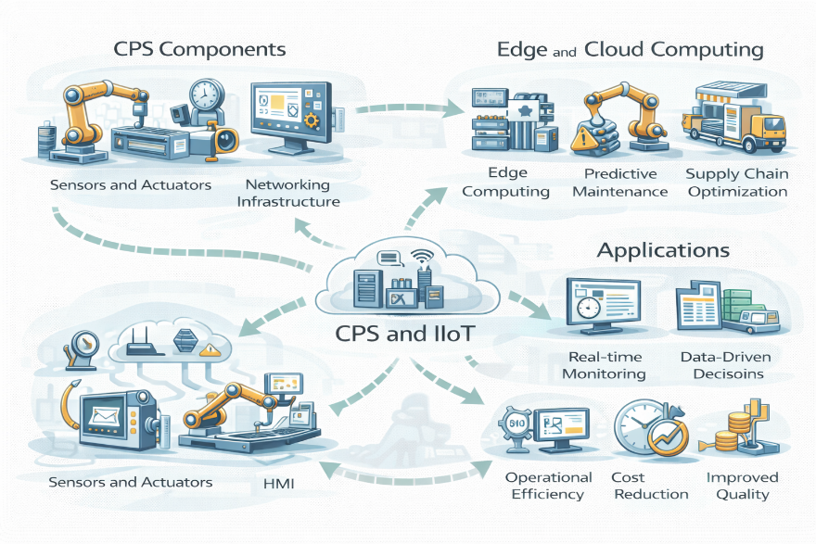
Fig. 16 Human–Machine Collaboration in Smart Industrial Environments
Vocabulary & Key Terms
Human–machine collaboration – Cooperative interaction between people and automated systems.
Collaborative robot (cobot) – A robot designed to work safely alongside humans.
Human–machine interface (HMI) – Interface allowing users to interact with machines.
Augmented reality (AR) – Digital overlays added to the physical environment.
Digital literacy – Ability to understand and work with digital systems.
Ergonomics – Design focused on human comfort and efficiency.
Adaptive workforce – Workers capable of learning and adjusting to new technologies.

Section 3 – Exercises
1. Match the term (A) to its definition (B).
A
- Collaborative robot
- HMI
- Augmented reality
- Ergonomics
- Digital literacy
B
a. Interface for interacting with machines
b. Ability to work effectively with digital systems
c. Robot designed for safe human interaction
d. Design approach focused on human comfort
e. Digital information overlaid on the real world
2. Complete the sentences:
- Cobots allow humans and machines to share the same ______.
- AR systems can reduce errors during complex ______ tasks.
3. Short-answer:
How does human–machine collaboration change workforce training needs?

Section 4 – Discussion / Application
Discuss the following:
- What skills will be most important for future technicians?
- How can organizations manage worker resistance to automation?
- What safety considerations are critical in collaborative environments?
- Does human–machine collaboration increase or reduce job satisfaction?
Use at least four key terms from Section 2 in your responses.

Chapter Outcome Checklist
By the end of this chapter, you should be able to:
- Describe human–machine collaboration in modern industry
- Explain changing roles in technical professions
- Use future-oriented technical vocabulary accurately
- Discuss workforce development in engineering contexts

Chapter 17: Warehouse Automation and Smart Logistics

1. Scaling Automated Logistics Operations
Modern warehouses are no longer simple storage facilities. They are highly automated environments where goods are received, stored, retrieved, and shipped using coordinated mechanical and digital systems. Automation improves speed, accuracy, and safety while reducing manual handling and operational cost.
In a large distribution centre, automated storage and retrieval systems move products between storage racks and picking stations. Autonomous guided vehicles and mobile robots transport materials across the warehouse floor, navigating using sensors, mapping software, and obstacle-avoidance algorithms. Conveyor networks connect receiving, sorting, packing, and shipping zones to maintain continuous material flow.
Warehouse management systems coordinate these activities in real time. Inventory levels are updated automatically using barcode scanning and radio-frequency identification technology, ensuring accurate stock visibility. Predictive analytics helps identify bottlenecks, equipment wear, or demand fluctuations before they disrupt operations.
For technical professionals, maintaining automated logistics requires both mechanical knowledge and digital system awareness. Reliability depends on the integration of sensors, control software, communication networks, and maintenance planning. As e-commerce and global distribution continue to grow, warehouse automation is becoming a critical component of industrial efficiency.

2. Smart Warehouse Architecture
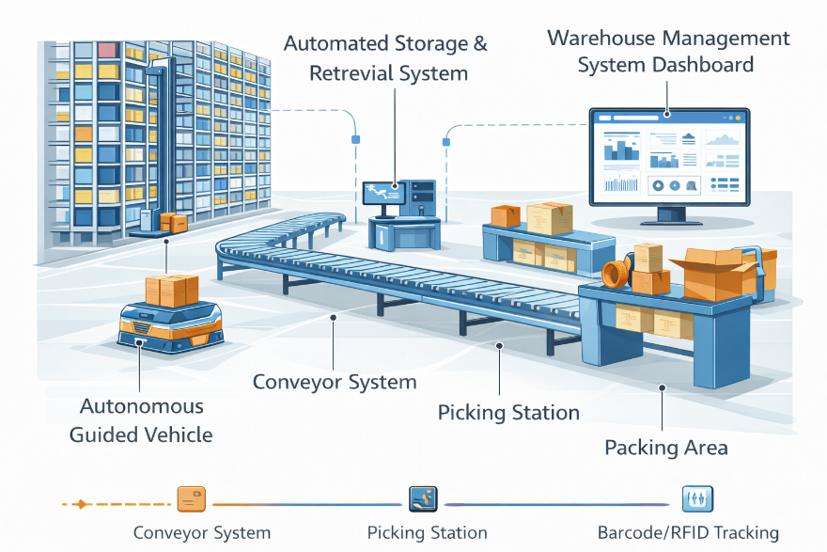
Fig. 17 Automated warehouse with storage racks, AGVs, conveyor systems, picking stations, and warehouse management software
Task A — Identify system components
Explain the role of the following elements:
- Automated storage and retrieval system (AS/RS)
- Autonomous guided vehicle (AGV) or mobile robot
- Conveyor and sorting system
- Picking and packing station
- Warehouse management system (WMS)
- Barcode or RFID tracking system
Task B — Describe operational flow
Using the diagram, explain how a product moves from receiving to shipping, including:
- storage allocation
- retrieval request
- order picking
- packaging and dispatch

3. Precision Vocabulary: Warehouse Automation
Task A — Complete the definitions
- The use of machines and software to manage storage and handling: __________
- A self-navigating vehicle used for material transport: __________
- Software that coordinates warehouse operations and inventory: __________
- Wireless technology used to identify and track items: __________
- Real-time knowledge of stock levels and locations: __________
- Data analysis used to anticipate future demand or failures: __________
Task B — Choose the correct option
- AGVs reduce manual transport and improve operational __________.
- Accurate tracking improves inventory __________ and order reliability.
- Predictive analytics helps prevent logistical __________ before they occur.

4. Communication Task: Improving Warehouse Efficiency
Scenario
A rapidly growing company is experiencing shipping delays and inventory errors in its warehouse.
Task
Prepare a short technical proposal that:
- Identifies two causes of inefficiency
- Recommends one automation improvement
- Explains how data tracking and analytics will improve performance
Use at least six technical terms from this chapter.
Refer to material flow, tracking, and system integration.
Present your proposal in clear professional English.

Chapter Outcome Checklist
By the end of this chapter, you should be able to:
- Describe the structure and operation of an automated warehouse.
- Explain the role of AGVs, WMS software, and tracking systems.
- Use logistics and automation vocabulary accurately.
- Propose technical improvements to warehouse efficiency.

Chapter 18: Supply Chain Visibility and Data Integration

1. Managing End-to-End Industrial Flow
Modern supply chains extend across suppliers, manufacturers, warehouses, and distribution networks. To operate efficiently, organizations require continuous visibility of materials, components, and finished products throughout this entire system. Digital technologies now make real-time monitoring and coordination possible.
Enterprise resource planning platforms act as central data hubs, integrating procurement, production, inventory, and delivery information. Technologies such as GPS tracking, RFID identification, and cloud dashboards provide continuous updates on product location and condition. This transparency allows rapid response to disruptions such as supplier delays, transportation failures, or sudden demand changes.
Data integration also supports forecasting and strategic planning. By combining historical trends with real-time information, companies can optimise stock levels, reduce waste, and improve delivery reliability. Engineers and logistics specialists must therefore understand not only physical transport systems but also data architecture and interoperability between digital platforms.
Effective supply chain visibility transforms logistics from a reactive process into a predictive, data-driven system that supports resilience, efficiency, and global coordination.

2. Integrated Supply Chain Platform
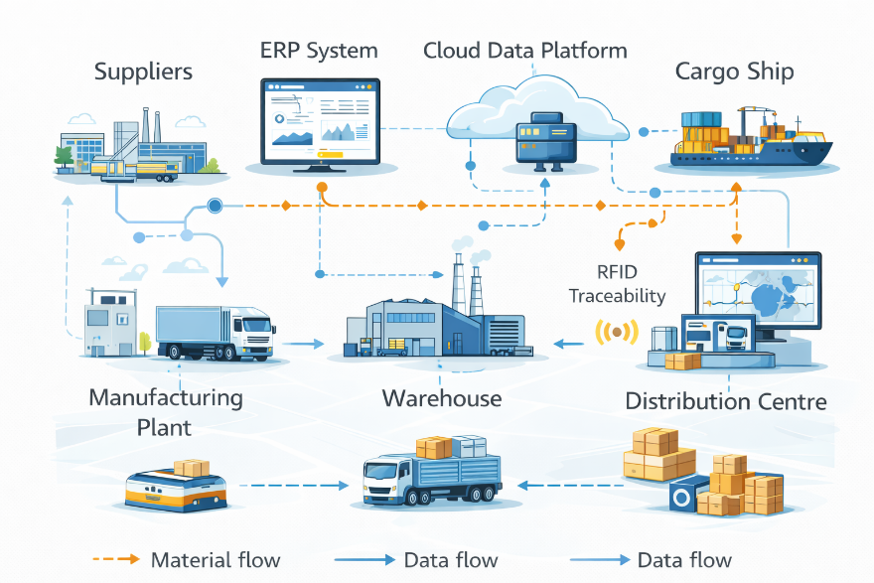
Fig. 18 Connected supply chain showing suppliers, transport networks, warehouses, ERP systems, and real-time dashboards
Task A — Identify digital components
Explain the function of:
- Enterprise Resource Planning (ERP) system
- GPS or location-tracking technology
- RFID-based traceability
- Cloud data dashboard
- Supplier and logistics data interfaces
Task B — Analyse data integration
Describe how real-time data improves:
- Demand forecasting
- Inventory optimisation
- Disruption response
- Delivery reliability

3. Precision Vocabulary: Supply Chain Systems
Task A — Match terms to definitions
1. ERP system
2. Traceability
3. Data integration
4. Supply chain visibility

Definitions:
a. Reducing the impact of potential disruptions
b. Combining information from multiple systems
c. Tracking products through all lifecycle stages
d. Integrated software managing business processes
e. Real-time insight into logistics and flows

Task B — Complete the sentences
- Real-time data improves delivery __________ and planning accuracy.
- Integrated systems support faster __________ to supply disruptions.
- Traceability ensures product __________ across the entire chain.

4. Communication Task: Strengthening Supply Chain Resilience
Scenario
A manufacturer experiences frequent delivery delays and poor coordination with suppliers.
Task
Prepare a short strategic recommendation that:
- Identifies two visibility problems in the supply chain
- Proposes one digital integration solution
- Explains how real-time data improves resilience and efficiency
Use at least six technical terms from this chapter.
Refer to forecasting, traceability, and risk mitigation.
Present your ideas in clear professional English.

Chapter Outcome Checklist
By the end of this chapter, you should be able to:
- Explain the concept ..
- Describe how ERP systems and tracking technologies integrate data.
- Use logistics and data-integration vocabulary accurately.
- Discuss strategies for improving supply chain resilience.

Chapter 19: Quality Assurance, Metrology, and Testing

1. Ensuring Product Conformity
Quality assurance ensures that products meet defined specifications, safety requirements, and customer expectations. In industrial environments, quality is maintained through structured testing, measurement, and inspection processes applied throughout production. Rather than relying solely on final checks, modern quality systems focus on continuous monitoring and prevention of defects.
Metrology plays a central role by providing accurate measurement of dimensions, tolerances, and physical properties. Coordinate measuring machines, laser scanners, and calibrated sensors are used to verify that components conform to design standards. Test data is recorded digitally, enabling trend analysis and early detection of deviations.
Automated testing systems increasingly replace manual inspection, improving consistency and speed. Vision systems, non-destructive testing methods, and statistical process control tools allow engineers to identify process instability before it leads to failures. For technicians, understanding measurement uncertainty and calibration procedures is essential, as inaccurate data can compromise quality decisions. Quality assurance therefore combines technical measurement, data analysis, and disciplined procedures to ensure reliable and compliant production.

2. Quality Control and Measurement Setup
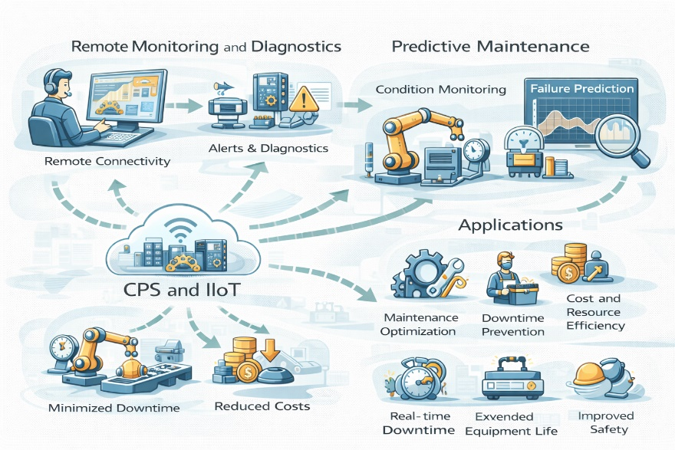
Fig. 19 Quality Assurance, Metrology, and Predictive Testing Systems
Vocabulary & Key Terms
Quality assurance (QA) – Systematic processes ensuring product quality.
Metrology – Science of measurement.
Tolerance – Permissible variation in a dimension.
Calibration – Adjustment of measurement instruments.
Non-destructive testing (NDT) – Inspection without damaging components.
Statistical process control (SPC) – Monitoring process variation using data.

Section 3 – Exercises
Match the term (A) to its definition (B).
A
- Metrology
- Calibration
- Tolerance
- NDT
- SPC
B
a. Measurement without damaging materials
b. Acceptable dimensional variation
c. Adjusting instruments for accuracy
d. Data-based monitoring of processes
e. Science of measurement

Section 4 – Discussion / Application
Task
Discuss:
- Why is prevention more effective than final inspection?
- How does automation improve quality assurance?

Chapter Outcome Checklist
By the end of this chapter, you should be able to:
- Explain the role of quality assurance and quality control
- Describe basic metrology and testing principles
- Use QA and measurement vocabulary accurately
- Discuss quality improvement in industrial contexts

Chapter 20: Standards, Regulation, and Compliance

1. Meeting International Requirements
Standards and regulations define the rules that govern industrial design, production, and operation. International standards organizations develop technical specifications to ensure safety, interoperability, and quality across industries. Compliance with these standards is often mandatory, particularly in sectors such as energy, healthcare, and transportation.
Engineers must design systems that meet regulatory requirements from the earliest stages of development. This includes material selection, safety features, documentation, and testing procedures. Audits and certification processes verify compliance and provide assurance to customers and authorities. Failure to comply can result in legal penalties, product recalls, or loss of market access.
Regulatory environments evolve as technologies change. Emerging fields such as AI-driven systems and autonomous machinery present new challenges for regulators and manufacturers alike. Technical professionals must therefore stay informed about applicable standards and understand how to interpret them in practical design and operational contexts. Compliance is not simply a legal obligation, but a framework for responsible and reliable engineering practice.

2. Compliance and Certification Framework
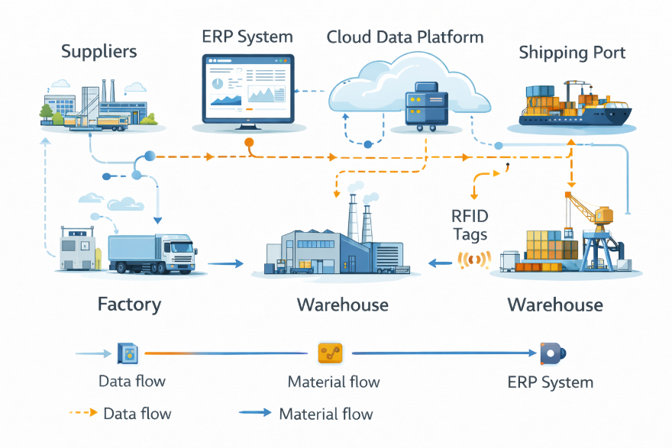
Fig. 20 Compliance and Certification Data Flow in a Digitally Integrated Supply Chain
Vocabulary & Key Terms
Standard – Agreed technical specification.
Regulation – Legal requirement enforced by authorities.
Compliance – Adherence to rules and standards.
Certification – Formal confirmation of compliance.
Audit – Systematic review of processes and documentation.

Section 3 – Exercises
Match the term (A) to its definition (B).
A
- Compliance
- Audit
- Regulation
- Certification
- Standard
B
a. Legal requirement
b. Independent review process
c. Following required rules
d. Formal proof of conformity
e. Agreed technical specification

Section 4 – Discussion / Application
Task
Discuss:
- Do standards encourage or limit innovation?
- Who should be responsible for ensuring compliance?

Chapter Outcome Checklist
By the end of this chapter, you should be able to:
- Explain the role of standards and regulation in engineering
- Describe certification and audit processes
- Use compliance-related technical vocabulary accurately
- Discuss regulatory requirements in professional contexts

Chapter 21: Technology Project Management and Risk Control

1. Planning and Delivering Technical Projects
Technical projects in engineering and industry involve coordinated activities, defined objectives, limited resources, and strict deadlines. Effective project management ensures that complex systems are designed, implemented, and delivered safely, on time, and within budget.
A typical project begins with requirement definition and feasibility analysis. Engineers identify technical specifications, performance targets, regulatory constraints, and resource availability. This information forms the project scope and guides planning decisions.
Project planning includes scheduling tasks, allocating personnel, estimating costs, and identifying dependencies between activities. Tools such as Gantt charts, critical path analysis, and digital collaboration platforms help teams monitor progress and coordinate work across departments or locations.
Risk management is an essential component of technical project control. Potential risks may include equipment failure, supply delays, budget overruns, safety hazards, or regulatory non-compliance. By identifying risks early, teams can develop mitigation strategies such as redundancy, alternative suppliers, safety procedures, or schedule adjustments.
Successful technical projects depend not only on engineering expertise but also on communication, documentation, and continuous monitoring. Clear reporting and stakeholder coordination ensure transparency and support informed decision-making throughout the project lifecycle.

2. Project Lifecycle and Risk Management Framework
Fig. 21 Technical project lifecycle showing planning, execution, monitoring, and closure with integrated risk assessment

Task A — Identify lifecycle stages
Explain the purpose of each stage:
- Requirements and feasibility
- Planning and scheduling
- Implementation and testing
- Monitoring and control
- Project closure and evaluation

Task B — Analyse project risks
For a new industrial automation project, identify:
- one technical risk
- one financial risk
- one safety or regulatory risk
Describe a mitigation strategy for each.

3. Precision Vocabulary: Project Management
Task A — Complete the definitions
- The defined boundaries and objectives of a project: __________
- The sequence of tasks determining minimum project duration: __________
- Actions taken to reduce the impact of potential problems: __________
- Monitoring progress compared with the original plan: __________
- The final phase where outcomes are reviewed and documented: __________
Task B — Choose the correct option
- Effective scheduling helps prevent project __________ and delays.
- Risk mitigation improves safety, cost control, and delivery __________.
- Clear communication supports stakeholder __________ and transparency.

4. Communication Task: Managing a Technical Project
Scenario
An engineering team must implement a new automated production system within a fixed budget and deadline.
Task
Prepare a short project briefing that:
- Defines the project scope and objectives
- Identifies two major risks and mitigation strategies
- Explains how progress will be monitored and reported
Use at least six technical terms from this chapter.
Refer to schedule, cost, safety, and performance.
Present your plan in clear professional English.

Chapter Outcome Checklist
By the end of this chapter, you should be able to:
- Describe the lifecycle of a technical project.
- Explain risk identification and mitigation strategies.
- Use project management vocabulary accurately.
- Communicate project plans in professional technical English.

Chapter 22: The Future Technical Workforce & Industry Trends

1. Adapting to Rapid Technological Change
Industrial technology is evolving at an unprecedented speed. Automation, artificial intelligence, digital connectivity, and advanced manufacturing are transforming how work is performed across engineering and technical professions. As routine manual tasks become increasingly automated, the role of the technical workforce is shifting toward supervision, analysis, and decision-making.
Future technicians and engineers must combine traditional mechanical and electrical knowledge with digital competencies such as data interpretation, system integration, and cybersecurity awareness. Rather than operating isolated machines, professionals now manage interconnected systems that communicate continuously through industrial networks and cloud platforms.
Lifelong learning is therefore essential. Technical skills that were once sufficient for an entire career may now require regular updating. Training programs increasingly emphasize adaptability, problem-solving, and collaboration between humans and intelligent machines. Soft skills—including communication, teamwork, and critical thinking—are becoming as important as technical expertise.
Global industry trends also influence workforce development. Remote monitoring, distributed production, and digital collaboration allow technical teams to work across geographic boundaries. Sustainability requirements create demand for specialists in energy efficiency, environmental compliance, and circular manufacturing. At the same time, ethical considerations surrounding artificial intelligence and automation require responsible engineering judgment.
The future technical workforce will not be defined only by machines, but by the ability of people to work effectively with advanced technology. Organizations that invest in continuous training and human–machine collaboration will be better prepared for long-term industrial transformation.

2. Future Industrial Ecosystem
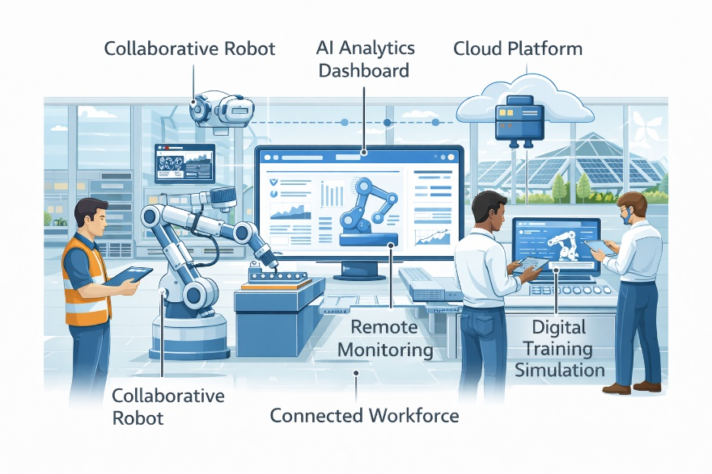
Fig. 22 Future smart factory with connected workforce, AI systems, collaborative robots, remote monitoring dashboards, and sustainable energy integration

Task A — Identify emerging elements
Explain the role of the following components in a future industrial environment:
- Collaborative robots and autonomous systems
- AI-driven decision platforms
- Remote monitoring and cloud dashboards
- Digital training and simulation tools
- Renewable energy integration
- Connected global engineering teams

Task B — Analyse workforce transformation
Describe how technical job roles may change in the next decade, considering:
- Required technical skills
- Importance of continuous learning
- Human–machine collaboration
- Remote and distributed work

3. Precision Vocabulary: Future Skills and Industry Evolution
Task A — Complete the definitions
Write the correct technical term for each definition.
- The ability to continuously learn and adapt to new technologies: __________
- Working together with intelligent automated systems: __________
- Skills related to understanding and using digital technologies: __________
- Production systems designed to minimize waste and reuse resources: __________
- Monitoring and controlling systems from a distant location: __________

Task B — Choose the correct option
- AI and automation are transforming traditional __________ roles into analytical and supervisory positions.
- Continuous professional development supports long-term __________ adaptability.
- Sustainable engineering reduces environmental __________ while maintaining productivity.

4. Communication Task: Preparing for the Future of Work
Scenario
A manufacturing company is planning its long-term workforce strategy for the next ten years.
Task
Working in pairs or small groups, prepare a short strategic recommendation that:
- Identifies three key skills future technicians will need
- Explains how training programs should evolve
- Describes the role of human–machine collaboration in future production
Use at least six technical terms from this chapter.
Refer to automation, digital skills, and sustainability.
Present your ideas clearly in professional English.

Chapter Outcome Checklist
By the end of this chapter, you should be able to:
- Describe major trends shaping the future technical workforce.
- Explain how automation and AI are changing engineering roles.
- Use future-oriented technical vocabulary accurately.
- Discuss workforce development and lifelong learning in professional contexts.

Answers to Section 3 Exercises

Chapter 1 – Industrial Production Lines and Workflow
Matching
1 → c, 2 → e, 3 → a, 4 → b, 5 → d
Sentence completion (sample answers)
- Production lines improve efficiency and reduce manual handling.
- Workflow coordination ensures continuous material movement.
Short-answer (model answer)
Industrial production lines organise machines and workers into a logical sequence that increases productivity, quality consistency, and operational safety.

Chapter 2 – Sensors, Measurement, and Data Acquisition
Matching
1 → d, 2 → b, 3 → e, 4 → a, 5 → c
Sentence completion (sample answers)
- Sensors convert physical variables into measurable signals.
- Data acquisition systems collect and store measurement data.
Short-answer (model answer)
Accurate sensing and measurement allow engineers to monitor performance, detect faults, and maintain system reliability.

Chapter 3 – Automated Packaging Systems
1. Matching
1 → b, 2 → e, 3 → a, 4 → d, 5 → c
Sentence completion (sample answers)
- Automated packaging increases speed and consistency.
- Sensors ensure correct positioning and sealing quality.
Short-answer (model answer)
Automated packaging systems integrate conveyors, sensors, and sealing mechanisms to improve efficiency and reduce human error.

Chapter 4 – Robotics in Manufacturing and Assembly
1. Matching
1 → c, 2 → a, 3 → e, 4 → b, 5 → d
Sentence completion (sample answers)
- Industrial robots perform repetitive assembly tasks accurately.
- Safety systems protect operators during robotic operation.
Short-answer (model answer)
Robotic automation improves productivity, precision, and workplace safety in modern manufacturing environments.

Chapter 5 – Programmable Logic Controllers and Control Systems
1. Matching
1 → b, 2 → e, 3 → a, 4 → d, 5 → c
Sentence completion (sample answers)
- PLCs control machines using programmed logic.
- Input and output signals coordinate system behaviour.
Short-answer (model answer)
Programmable logic controllers enable reliable, automated control of industrial processes through real-time monitoring and logic execution.

Chapter 6 – Predictive Maintenance and Industrial IoT
1. Matching
Sentence completion (sample answers)
- Predictive maintenance uses sensor data to anticipate failures.
- Industrial IoT connects machines to cloud analytics platforms.
Short-answer (model answer)
Predictive maintenance reduces downtime and maintenance cost by identifying equipment problems before failure occurs.

Chapter 7 – Digital Twins and Simulation Models
1. Matching
1 → e, 2 → c, 3 → a, 4 → d, 5 → b
Sentence completion (sample answers)
- Digital twins replicate physical systems virtually.
- Simulation allows safe testing of operating conditions.
Short-answer (model answer)
Digital twin technology enables real-time monitoring, optimisation, and predictive analysis of industrial assets.

Chapter 8 – Additive Manufacturing and Rapid Prototyping
1. Matching
1 → a, 2 → e, 3 → b, 4 → d, 5 → c
Sentence completion (sample answers)
- Additive manufacturing builds components layer by layer.
- Rapid prototyping accelerates product development.
Short-answer (model answer)
Additive technologies allow fast design testing, complex geometries, and reduced material waste in engineering production.

Chapter 9 – Materials Engineering and Advanced Composites
1. Matching
1 → d, 2 → b, 3 → a, 4 → e, 5 → c
Sentence completion (sample answers)
- Composite materials combine strength and low weight.
- Material selection affects durability and performance.
Short-answer (model answer)
Advanced materials improve efficiency, reliability, and structural performance in modern engineering applications.

Chapter 10 – Energy Systems and Smart Grids
1. Matching
1 → e, 2 → c, 3 → a, 4 → b, 5 → d
Sentence completion (sample answers)
- Smart grids balance electricity supply and demand.
- Renewable energy sources reduce environmental impact.
Short-answer (model answer)
Modern energy systems integrate digital monitoring and renewable generation to improve sustainability and reliability.

Chapter 11 – Warehouse Automation and Smart Logistics
1. Matching
1 → d, 2 → b, 3 → c, 4 → e, 5 → a
Sentence completion (sample answers)
- Automated storage improves efficiency and accuracy.
- Logistics software coordinates inventory and transport.
Short-answer (model answer)
Warehouse automation enables faster order processing, accurate tracking, and reduced operational cost.

Chapter 12 – Automation, Robotics, and Control Systems
1. Matching
1 → a, 2 → e, 3 → b, 4 → d, 5 → c
Sentence completion (sample answers)
- Integrated automation combines robotics and control logic.
- Control systems maintain stable industrial operation.
Short-answer (model answer)
Automation and control technologies coordinate machines, sensors, and software to achieve reliable industrial production.

Chapter 13 — Additive Manufacturing
Vocabulary Definitions
- Additive manufacturing
- CAD model
- Slicer software
- Post-processing
- Tolerance
- In-process monitoring
Choose the Correct Option
- Heat
- Subtractive
- Channels / geometries

Chapter 14 — Digital Twins
Vocabulary Definitions
- Digital twin
- Simulation
- Performance indicator / metric
- Anomaly
- Predictive maintenance
- Lifecycle management
Choose the Correct Option
- Data
- Physical / live
- Failures

Chapter 15 – Sustainability and Green Engineering
1. Matching
1 → b, 2 → e, 3 → a, 4 → d, 5 → c
Sentence completion (sample answers)
- Sustainable design reduces waste and emissions.
- Energy efficiency lowers environmental impact.
Short-answer (model answer)
Green engineering focuses on resource efficiency, renewable energy, and environmentally responsible production.

Chapter 16 – Human–Machine Collaboration and the Future Technical Workforce
1. Matching
1 → c, 2 → a, 3 → e, 4 → d, 5 → b
2. Sentence completion (sample answers)
- Cobots allow humans and machines to share the same workspace.
- AR systems can reduce errors during complex assembly tasks.
3. Short-answer (model answer)
Human–machine collaboration requires training in digital systems, data interpretation, and system supervision rather than purely manual skills.

Chapter 17 — Warehouse Automation
Vocabulary Definitions
- Automation
- Autonomous guided vehicle (AGV)
- Warehouse management system (WMS)
- RFID
- Inventory visibility
- Predictive analytics
Choose the Correct Option
- Efficiency
- Accuracy
- Disruptions / bottlenecks

Chapter 18 — Supply Chain Visibility
Matching Terms
- ERP system → Integrated software managing business processes
- Traceability → Tracking products through lifecycle stages
- Data integration → Combining information from multiple systems
- Supply chain visibility → Real-time insight into logistics flows
- Risk mitigation → Reducing impact of disruptions
Sentence Completion
- Reliability / performance
- Response
- Transparency / tracking

Chapter 19 – Quality Assurance, Metrology, and Testing
Matching
1 → c, 2 → a, 3 → e, 4 → b, 5 → d
Sentence completion (sample answers)
- Quality assurance ensures consistent product standards.
- Measurement accuracy is essential for testing reliability.
Short-answer (model answer)
Metrology and testing verify that manufactured components meet required specifications and safety standards.

Chapter 20 – Standards, Regulation, and Compliance
Matching (sample solution)
1 → b, 2 → d, 3 → a, 4 → e, 5 → c
Sentence completion (sample answers)
- Standards define technical and safety requirements.
- Compliance ensures legal and regulatory approval.
Short-answer (model answer)
Regulation and compliance protect users, ensure product reliability, and support international trade.

Chapter 21 — Project Management
Vocabulary Definitions
- Scope
- Critical path
- Mitigation
- Monitoring / control
- Closure
Choose the Correct Option
- Overruns / delays
- Performance / reliability
- Alignment / communication

Chapter 22 — Future Workforce
Vocabulary Definitions
- Adaptability / lifelong learning
- Human–machine collaboration
- Digital literacy / digital skills
- Sustainable / circular production
- Remote monitoring
Choose the Correct Option
- Manual / routine
- Adaptability / resilience
- Impact / footprint

2. Sentence completion (sample answers)
- Global engineering projects require clear and precise communication in English.
- Digital collaboration tools allow teams to work across different countries and time zones.
- Standardised technical terminology reduces misunderstanding and improves efficiency.
3. Short-answer (model answer)
Effective global technical communication depends on clear language, shared terminology, and reliable digital collaboration tools. These elements allow international engineering teams to coordinate tasks, solve problems, and complete projects successfully.

Index (by chapter number)
A
additive manufacturing, 13
air quality monitoring, 6
anomaly detection, 14
artificial intelligence (AI), 14, 22
autonomous guided vehicles (AGVs), 17
automated packaging systems, 3
automation, 17, 22
B
barcode tracking, 17
build platform, 13
C
CAD models, 13
cloud analytics, 6, 14
cloud platforms, 14, 22
collaborative robots, 22
communication networks, 12
control systems, 5
critical path, 21
cybersecurity, 13
D
data acquisition, 2
data integration, 18
data transmission, 6
data-driven optimisation, 14
digital literacy, 22
digital twin, 14
distributed production, 22
E
Electron Beam Melting (EBM), 13
embedded sensors, 14
end-to-end supply chain, 18
energy efficiency, 10, 22
Enterprise Resource Planning (ERP), 18
F
fault detection, 6
forecasting, 18
G
Gantt charts, 21
GPS tracking, 18
H
human–machine collaboration, 22
hybrid manufacturing, 13
I
in-process monitoring, 13
industrial Internet of Things (IIoT), 6
industrial robotics, 4
inventory visibility, 17
L
laser sintering, 13
lifecycle management, 14
logistics automation, 17
M
machine learning, 14
maintenance alert, 6
material feedstock, 13
mobile robots, 17
P
performance metrics, 14
picking systems, 17
post-processing, 13
predictive analytics, 17, 18
predictive maintenance, 6, 14
project closure, 21
project lifecycle, 21
project scope, 21
Programmable Logic Controller (PLC), 5
Q
quality assurance, 21
R
real-time monitoring, 6, 14, 18
remote monitoring, 22
renewable energy, 22
risk assessment, 21
risk mitigation, 18, 21
robotic arm, 4
S
scheduling, 21
sensors, 2, 6, 14
simulation, 14, 22
slicer software, 13
smart factory, 22
supply chain visibility, 18
sustainability, 22
T
tolerance, 13
traceability, 18
V
vibration monitoring, 6
W
warehouse management system (WMS), 17
warehouse automation, 17
workforce development, 22

Hybrid English 5.0
Where Artificial Intelligence Meets Human Expertise
Hybrid English 5.0 is an innovative method for developing real fluency in professional English.
It was created by Rikki J Prince, specialist in technical and professional English training and author of this work as well as the Sarah Mackay saga of novels. (Search for Nine Days in Particle Physics (in Geneva) for a free sample.
The method combines the power of artificial intelligence conversation systems with the guidance of a human teacher, tutor, consultant, and coach. The result is a modern learning system that integrates the efficiency of advanced technology with the personal support that serious learners still need.
Many language-learning platforms rely entirely on automated systems. Others depend exclusively on traditional teaching methods. Hybrid English 5.0 brings these two worlds together.
Students use AI tools to practice conversation, simulate professional situations, and expand their vocabulary through continuous interaction. At the same time, they work with a human expert who helps them refine their communication, correct errors, develop strategy, and build real confidence in professional contexts.
The method is called Hybrid English 5.0 for two reasons.
First, it is hybrid: it combines the scalability and responsiveness of AI with the insight, judgement, and experience of a human instructor.
Second, it is designed for Society 5.0 — the emerging global society in which artificial intelligence, advanced technology, and digital networks are integrated into every area of life, work, and communication.
In this environment, professionals must communicate clearly across cultures, disciplines, and industries. English remains the global language of engineering, science, technology, and international collaboration.
Hybrid English 5.0 prepares learners for this reality.

How Hybrid English 5.0 Works
Step 1 — AI Conversation Practice
Students interact with advanced AI systems to develop fluency, vocabulary, and confidence through constant practice.
Step 2 — Expert Human Guidance
A specialist teacher analyses performance, corrects errors, and provides personalised coaching.
Step 3 — Real Professional Simulation
Students practice meetings, presentations, negotiations, and technical explanations in realistic scenarios.

Who Is It For?
Hybrid English 5.0 is particularly effective for:
• engineers
• scientists
• technicians
• university students in technical fields
• professionals working in international environments
The goal is simple:
to transform English from a subject of study into a powerful professional tool.

Learn More
Visit:
rikkijprince.com
to explore the Hybrid English 5.0 method of fluency in spoken English.

